Singapore Chinese New Year

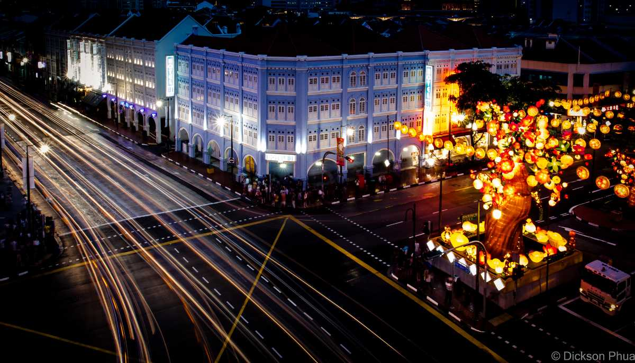

The first day of Chinese New Year, also known as the Spring Festival in Singapore, falls on the new moon day. The Lunar New Year (as it is also called) is of great significance to the Chinese who clean their homes to get rid of the bad or the ill-fortune and make way for good luck.

The celebration of this grand festival in Singapore continues for 14 days starting on the eve of the New Years. During this time, the Chinese locals visit their families and decorate their homes with red and gold colours. They also exchange gifts and give kids Hong Bao (red envelopes).

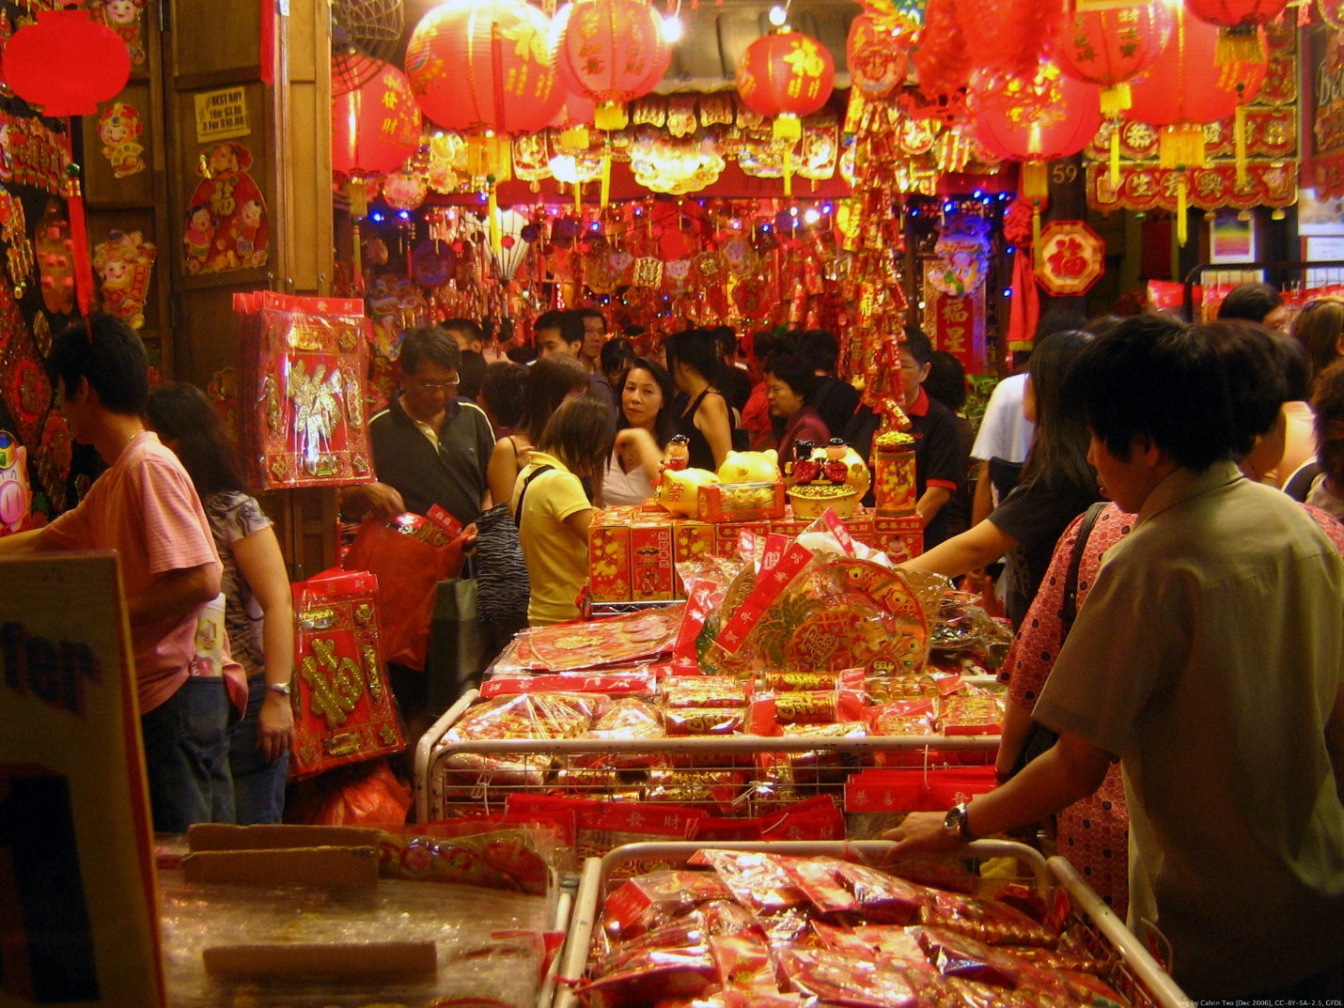

The Chinatown comes to life through the celebration of festivities. Lion and dragon dances performed as a part of the celebration.

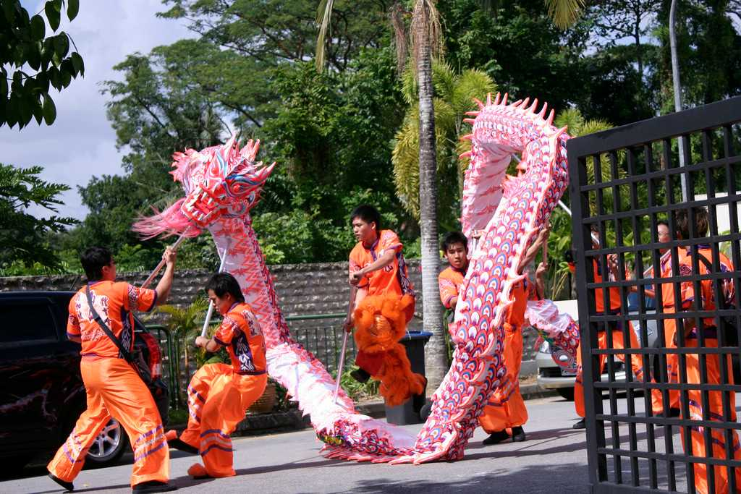

During the Chinese new-year celebration, houses are cleaned and beautifully decorated. The malls and streets are dolled up with bright red and extravagant decorations.

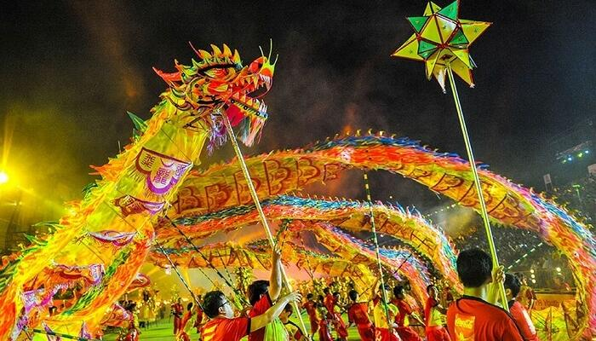

**Don’t miss:**Dragon Dance and Chingay parade at Marina Bay  
**When:**25th – 26th January 2020